  EXTEND | 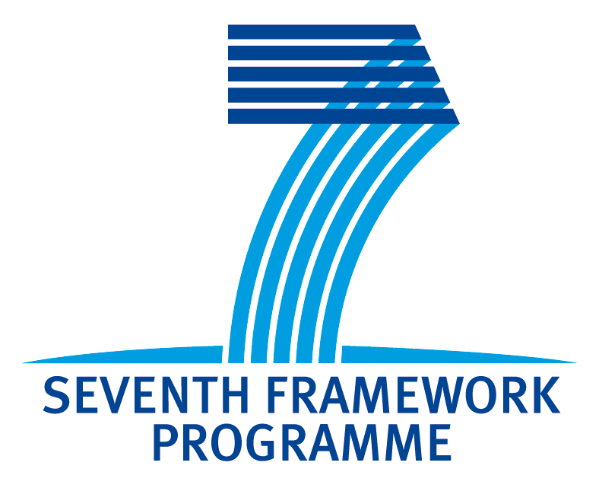 | 

EXTEND Training Workshop
Application Form
Organisation:
Title(Dr.,Mr.,Mrs.,...):
First Name:
Last Name:
Function:
Department:
Organisation:
Street:
City:
Country:
Phone:
Mobile:
Fax:
Email:
URL:

About your Organisation:

Your idea for a Framework Project:

Consider the objectives of Call 8 of the ICT Work Programme 2011-2012 - (if you can’t match your activities with open objectives use any of the available ones in the work programme). What would you ideally like to propose for a project?
Briefly describe your idea from a technical point of view, keeping in mind that the topic should be in line with the activities of your organisation and their available skills and also be of relevance for both your country and Europe.
Please address
- business, societal and technological drivers of your idea,
- implementation details i.e. required skills- possible profile of partners,
- time, resources, etc,
- and expected impact with respect to EC’s requirements.
Please, send the application form to extend@asm.md not later than 21 of March 2011.

NOTE: PLEASE READ THE ICT WORK PROGRAMME 2011-2012 CAREFULLY BEFORE DRAFTING YOUR IDEAS

