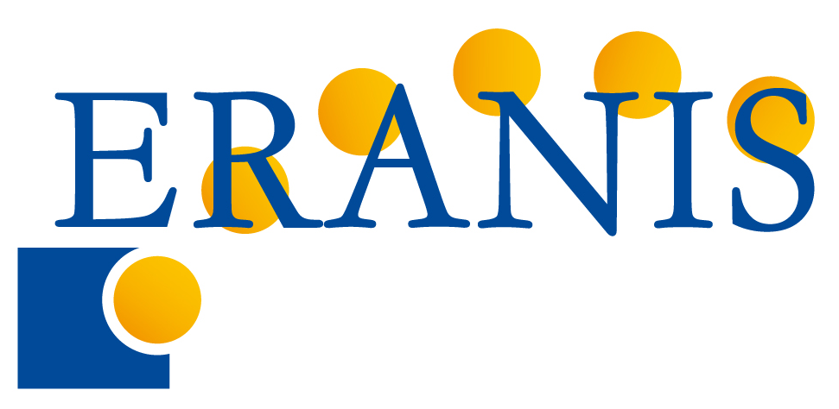 “Project preparation and management in FP7”
(CSRIEREA PROIECTULUI ŞI MANAGEMENTUL ÎN PC7)
LANGUAGE OF THE WORKSHOP: English.
The second round of workshops within ERANIS Project, conducted by Invent Baltics OÜ
Chisinau, Moldova, str. Academiei 5 a., Biblioteca Ştiinţifică Centrală „Andrei Lupan”, etaj. 2.
13 December 2007
WORKSHOP PROGRAMME
Time | Presentation | Speaker
9:00 - 9:10 | Opening & Introduction: NEW OPEN CALLS | Representative of local NIS country
9:10 - 10:00 | From idea to proposal
 | - The art of reading and understanding work-programme, fitting your expertise into the context of FP7 priorities  - Drafting and structuring the idea, compilation of competence diagram, background information sources | Tarmo Pihl, Invent Baltics
10:00 – 12:00 | Project preparation process | Tarmo Pihl, Invent Baltics
 | Partner search mechanisms, Drafting the proposal – objectives & work-plan, management & resources, impact & dissemination
12:00-12:30 | COFFE
12:30 - 13:15 | Short reminding of Financial rules in FP7 | Silver Toomla, Invent Baltics
13:15 - 14:30 | Evaluating proposals
 | Evaluations of proposals  Practical exercise: evaluation of proposal | Tarmo Pihl, Invent Baltics  all participants
14:30 – 15:00 | Project management issues | Silver Toomla, Invent Baltics
Reporting to the European Commission
Financial management
Roles of partners in the consortium
Consortium agreement
15:00 -16:00 | Questions & answers, summary | All speakers of the workshop

