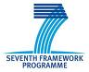 | 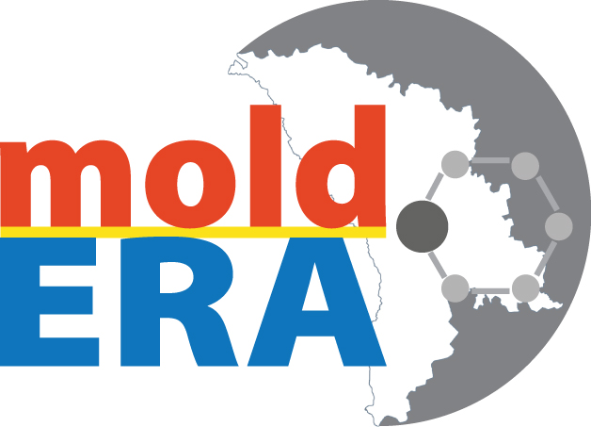

Marie-Curie Workshop
in the framework of MOLD-ERA project
(October 24-26, 2012)

Application Form

Title(Dr.,Mr.,Mrs.,...):
First Name:
Last Name:
Date of birth (dd/mm/yy):
Position:
Department:
Organisation:
Address:
Phone:
Mobile:
Fax:
Email:
URL:

Please, send the application form to project@mold-era.eu no later than 18 of October 2012.

